Introduction to Computer Hardware

Preface:

This document will attempt to explain how common hardware devices, microprocessors, and peripherals function at a low level. This means discussing various types of interfaces, communication protocols, components, etc. Originally, I had written this document to be biased towards Windows users without really realizing it. As a newborn avid user of the Linux operating system, and as someone who has gained more experience with embedded systems, I felt that it would be better to recreate this document with a more platform agnostic stance. I will focus much less on operating systems, and much more on the hardware itself. Much of this document will probably be dry, and there will be a lot of information thrown at you (including an obscene amount of abbreviations). I assure you that if you end up working with any sort of hardware this information will be quite beneficial to you, but I don’t expect you to remember everything, and you shouldn’t either. On an important note – this document will *not* focus on circuits, electrical components, or any of the physics behind electricity; that will be covered in a separate document.

Intro:

I pressume that you, the reader, are interested in becoming some sort of software developer, or data scientist, or any other field that deals a lot with software and problem solving. It may be the case that you will never need to actually interact with hardware in any hands-on sense. Perhaps you’ll never solder wires, adjust dip switches, or measure voltage, but it is important to understand how the hardware of a system works regardless. Software is an illusion – it really does not exist in any *tangeable* sense. Your monitor or TV turns millions of LED lights on or off in a large array to produce the illusion of color which can form then collectively form images which can then produce the perception of motion in video. Note that at no point, though, is any movement actually occuring. Similarily, we can interpret the presence of electrons as pulses that we nominally refer to as bits of information. But these are not truly numbers in any real sense, only logical states in space-time. My point is that if we are going to deal with software, even if much of it is abstracted away from the hardware, we still need to understand how systems operate at a low level if we want to be able to interface with it, manipulate it, or control it. I plan on taking you through a very low level journey through history to see the evolution of hardware, and the advancements we’ve made to come this far.

The Beggining of the Beggining:

Note: I will be skipping over much of the early 1900s. Despite computers not having been invented yet, their existence had been conceptualized with the advance of electronics, and partially realized with the introduction of complex machinery. We could say that “automata” were in their infancy at this stage. Automata, in case you aren’t familiar with the term, are any system that can automate some process. For instance, calculators were starting to be produced, and not the digital ones that we use today. Typewriters are another good example of automata. Many great thinkers like Von Neuman and Allan Turing were able to conceptualize how a system such as a computer might be able to function, but we hadn’t quite arrived there yet (unless you count computers like the Analytical Engine created by Charles Babbage in 1837). Between 1936 and 1938, the first binary programmable computer, the Z1, was created by Konrade Zuse. This is also when Turing proposed the Turing machine. In 1943, the Colossus was created to decode encrypted German messages. The ABC and ENIAC were invented around the same time. Another big milestone was the Whirlwind created by MIT in 1955. The Whirlwind was the first computer with RAM. In 1964 came the first desktop computer, the programma 101. All this stuff is a neat history lesson, but this document will begin with the invention of the first microprocessor, the Intel 4004.

Intel 4004:

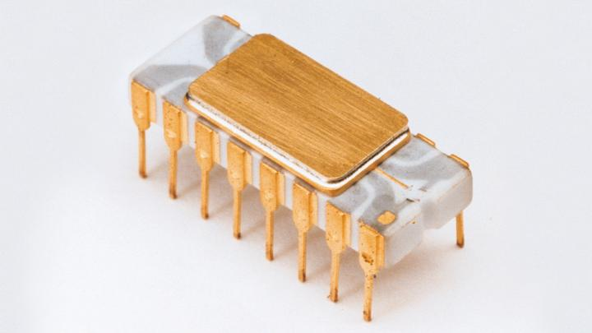 The Intel 4004 is considered by most people to be the first microprocessor. This chip looks disceptively simple. It has 16 pins (most processors have way more nowadays, even older chips like the 6502 or 8086). Despite appearing simple on the surface, we can see the internals of this chip under a microscope and view the complex circuitry that went into the making of the chip. The 4004 used Metal-Oxide-Semiconductor (MOS) silicon gate technology (SGT).

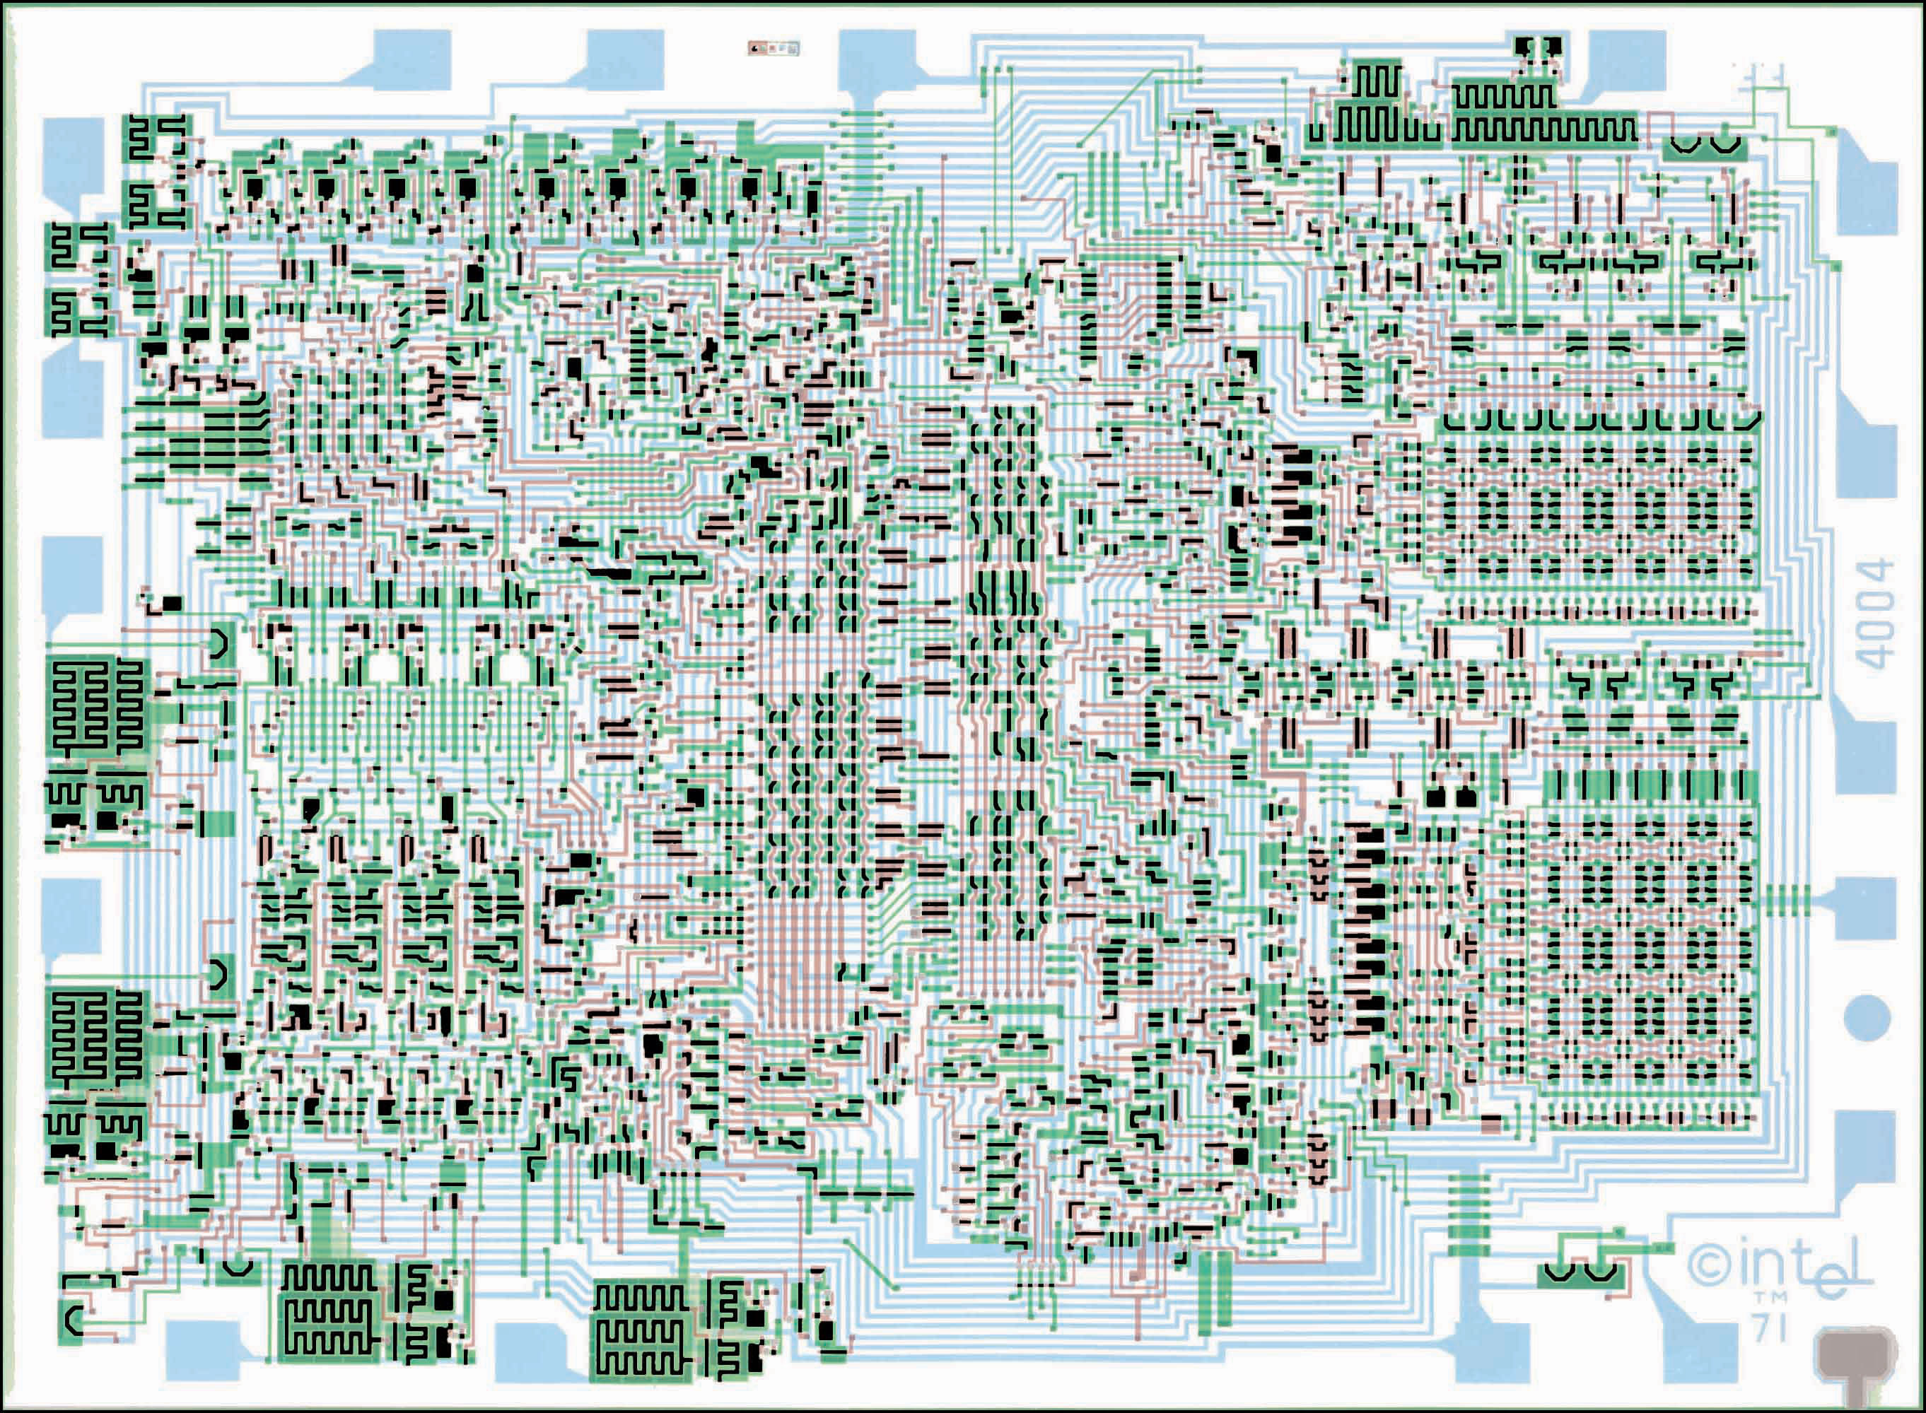

The word “microprocessor”, sometimes also refered to as the MicroProcessor Unit (MPU) is used to describe a chip that is able to combine all of the parts of a Central Processing Unit (CPU) into one integrated circuit. It used to be that the parts of a Central Processing Unit were split up into different Integrated Circuits (ICs). Nowadays, the word microprocessor is usually used to refer to a single chip or single core CPU, even though back then your CPU would be considered to be a microprocessor (now we just call it a CPU...)

Evolution of the Microprocessor:

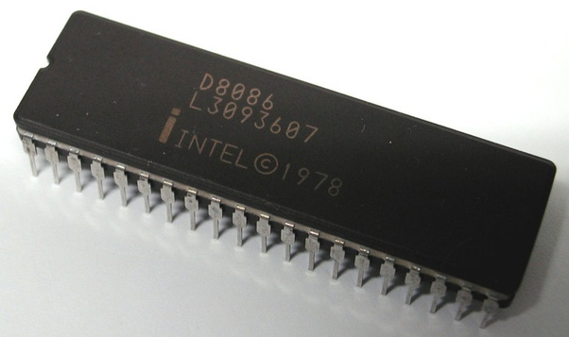  
  
 Despite Intel starting off as a company that designed RAM, after the introduction of the 4004, they shifted their focus to creating microprocessors. Following the 4004 came the 4040. After the 4000 series began their most popular line – the 8086 line of processors. In 1972, the 8008 was created, followed by the 8080. Next was the 8085. But their most revolutionary chip was the 8086 because it introduced the x86 architecture. A computers architecture is very important. The heart of any architecture is the instruction set. The instruction set can be thought of as a table of instructions or operations that can be executed by the processor. In the case of the 8086, it introduced the x86 instruction set (81 instructions) that could be performed by the 8086’s ICs. The architecture defines other things like the “word size”. The word size of a processor is the largest number of bits that a CPU/microprocessor can process at a time. The 8086 is a 16-bit microprocessor. That means that it’s word size is 16 bits. Intel would continue to create other microprocessors such as the 8088, 80186, 80188, 80286, 80836, and 80846. Finally, in 1993, Intel stopped with their silly naming scheme of larger and larger numbers, and decided on using real names for their processors. The Pentium, Pentium II, and Pentium III were released, as well as the Celeron series, Xeon series, and now, the Core series (i3, i5, i7, i9, etc.). For a more detailed list of all Intel processors released throughout the years and the different “generations” or “families” of Intel processors, check out this Wiki <https://en.wikipedia.org/wiki/List_of_Intel_processors>.

Other Microprocessors:

Intel weren’t the only microprocessors, however. Other companies such as Motorola also began manufacturing processors. These were largely used in Apple computers until about the 1990s. In 1989, Motorola changed its focus away from Complex Instruction Set Computer(s) (CISC) to Reduced Instruction Set Computer(s) (RISC). The trend at the time was for microprocessor companies to continuously one up each other by creating increasingly complex instruction sets that were capable of executing more and more instructions. Manufacturers eventually realized that this was not good design, and that ICs became too difficult to maintain. A new trend, RISC, arose with the mindset of “less is more”. In other words, a few powerful and useful instructions > many niche and specific ones. In 1993, Motorola joined forces with Apple and IBM to create a new computer architecture to rival x86, PowerPC. The word “power” in PowerPC is an anogram: **P**erformance **O**ptimization **W**ith **E**nhanced **R**ISC. The first computers to use this new architecture were the Power Macs, which appeared in 1994. IBM continues to use PowerPC, but it is not as common as other architectures in the modern era.

Zilog Z80:

The Z80 is an 8-bit microprocessor created by Zilog as the startup company’s first product. It was a software-compatible extension/enhancement to the Intel 8080, primarily targeted at embedded systems. It was common in military applications, musical equipment, and coin-operated arcade games e.g. Pacman.

Other Processor Architectures:

As I mentioned, the Instruction Set Architecture (ISA) of the processor is the thing that determines which instructions that processor will have, as well as what sorts of registers and other design factors it will have. Since designing a new ISA for every new processor that you release would be tedious and repetitive, companies like Intel and AMD have created families of processors that share the same ISA (for instance, the Intel ‘i’ series, which are based off of the 8086 family). The most common ISAs include the following:

**- x86 / IA-32 / i386:** Intel 32-bit (based off of the 8086 series of processor)

**- x86_64 / x64 / AMD64 / EM64T / IA-32e:** Intel 64-bit (backwards compatible with x86)

**- MIPS:** Microprocessor without Interlocked Pipelined Stages (RISC-based)

**- PowerPC (PPC):** Performance Optimization With Enhanced RISC(IBM’s ISA)

**- ARM:** Advanced RISC Machines. Arm is a company that develops architectures and licenses them to other companies. Many phone processors are based off of arm.

**- AARCH64:** ARM 64-bit

As a developer, you will most likely either deal with x86_64, or ARM, or AARCH64. x86_64 is without a doubt the most well known, and popular ISA, and is present in both Intel and AMD chips, which are the biggest CPU manufacturer competitors. The reason that ARM and AARCH64 are considered relevant is because almost every reference board or phone/tablet ever made uses them. ARM Ltd. (the company) licenses their designs to other companies such as Qualcomm and Snapdragon which makes them a popular choice for custom chips. PowerPC and MIPS on the other hand, are no longer used very often. For more information on ISAs, please see my Computer Hardware document.

The CPU:

The Central Processing Unit (CPU) is generally referred to as being the “heart” of the computer, and/or the “brain” of the computer. The CPU is without a doubt the most important part of any computer. A CPU operates at a particular frequency, measured in Hertz (Hz). The CPU has many bottlenecks when it comes to how fast it can execute (primarily heat produced by too much power draw). The CPU manufacturer tunes the CPU to consume a certain amount of power (around 1.4V by modern day standards) that will provide the best balance of high clock speeds and longevity. Other factors play a role as well, such as multi-cycle CPU instructions which are instructions that can execute more than once per clock cycle. To avoid confusion, we’ll just pretend that only one instruction is carried out per cycle. The clock is usually a dedicated circuit that pulses millions, if not billions of time per second, and controls the synchronization of the CPU. As I mentioned earlier, we measure the clock speed in Hertz (Hz). 1Hz = 1 pulse/second. 1MHz (megahertz) = 1,000,000 pulses/second. 1GHz (gigahertz) = 1,000,000,000 pulses/second. Most modern day CPUs are measured in GHz. A clock pulse differs from a CPU cycle, and both of those differ from a clock tick. A CPU pulse is the electrical pulse produced by the CPU’s clock. A CPU cycle is the amount of time that it takes for the CPU to execute a 1 step instruction. Instruction may take multiple cycles to complete, but 1 cycle would be the minimal time required to execute a CPU instruction such as a NOP instruction. Finally, a clock tick is usually a concept integrated in software, which specifies some amount of time by which threads of execution should abide. Typically, a clock tick is 1ms, which doesn’t sound like a lot, but this can allow for many CPU cycles, and therefore, many instructions to be executed.

Parts of a CPU:

There are really 3 primary pieces that make up a CPU. These are the Arithmetic and Logic Unit (ALU), the Control Unit (CU), and the Intermediate Access Store (IAS) which is more commonly known as the CPU’s registers. The ALU, as you may have guessed, is where all of our arithmetic is performed. To be a bit more specific, the instructions which are part of the CPU’s instruction set (recall the CPU architecture) are performed within the ALU. All of these instructions (sometimes called op-codes, short for operation codes), boil down to basic arithmetic and shifting or transferring of bits. The CU is in charge of fetching the next instruction from memory and handing it to the ALU to process. The CPU’s registers are very small storage banks that are physically located within the CPU, very close to the ALU. These are used for extremely quick read/write operations. The number of registers depends on the ISA of the CPU, as well as the number of bits that each register can store. Typically, different registers will be used for different purposes. Some are used for indexing, some for arithmetic, some for setting flags to keep track of the CPU’s state, some for general purpose (General Purpose Registers (GPR)), etc. You will often hear it said that the CPU goes through the following cycle:

1. Fetch

2. Decode

3. Execute

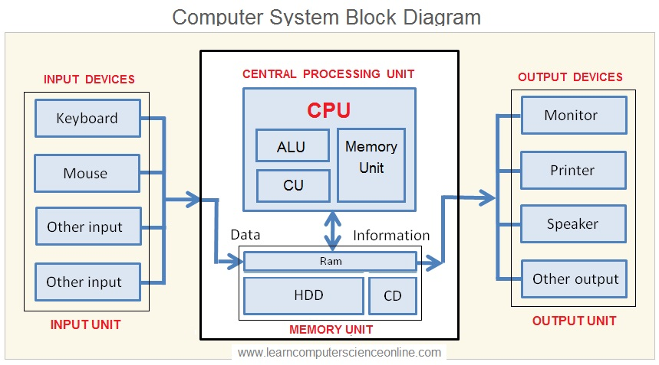The CPU does these 3 things on repeat. First, the CU fetches the next instruction. There is a register called the Instruction Pointer (IP), also sometimes called the Program Counter (PC), which points to the address of the next instruction in memory. The CU fetches the op-code from that address. Then, an IC known as the decoder will decide which gates to open depending on the instruction that was fetched by the CU (since not all instructions are created equal). We call this “decoding” an instruction, because by the end of the decoding phase, the correct gates in the circuit have been opened so that the instruction can be resolved. Finally, the ALU performs arithmetic, logical, and/or bitwise operations on the data that it is given, which is the execution stage. An optional fourth step is for the processor to write the result of the operation back to one of the registers or to memory.  
  
 Unfortunately, it was next to impossible for me to find a good diagram of the CPU. The one shown above is too basic for my liking, but it’s probably the best I could find. Notice that the CPU is always the center of attention. Everything else can be considered to be a sort of peripheral. Normally, we consider peripherals to mean “external to the physical computer”, like a mouse, a keyboard, or a flash drive, but the use of the word is subjective, and I like to use it in the sense that anything which is not the CPU is considered to be a peripheral. The input devices shown on the left-hand side communicate through some sort of bus. We will discuss what a “bus” is later, but all you need to know for now is that a bus is some set of wires or traces that connect a peripheral to the CPU, or to another peripheral. For example, USB stands for Universal Serial *Bus*. An input device like a mouse or keyboard might connect to the USB port, which sends the data down the bus, and it eventually ends up in RAM. Another bus connects the RAM to the CPU so that the CU can fetch instructions from RAM, decode them, and execute them. Note that the CPU can also write values to output devices like your monitor, printer, or speaker (also via some sort of bus).

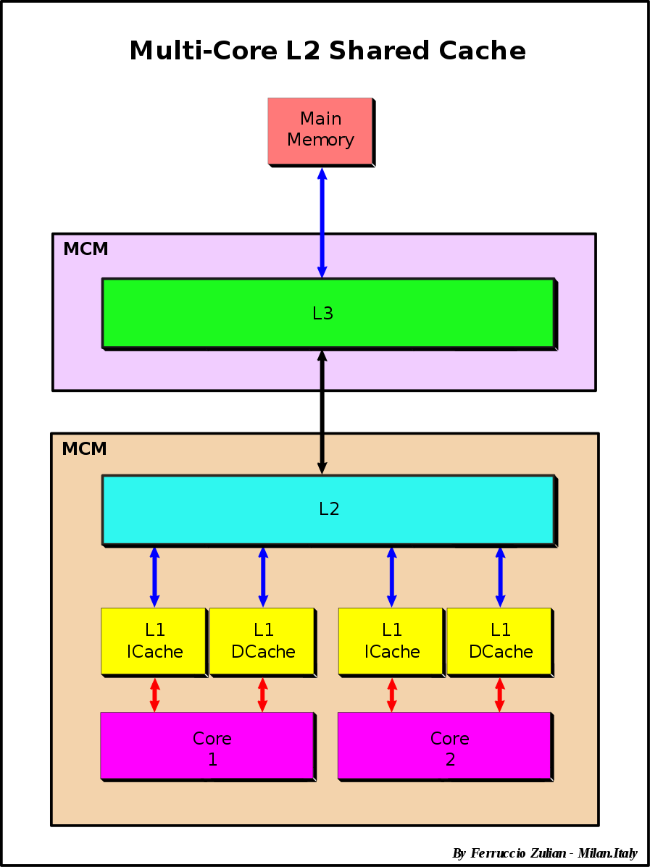 The “Memory Unit” is something that we didn’t really cover. That is because the Memory Unit is sort of optional, and can vary between CPUs. Usually, the Memory Unit = Registers + Cache. We’ve discussed registers already; they are very small storage locations with very high speed read/write access. Modern CPUs almost all have cache as well. Cache is another form of storage, similar to registers. There are 2 types of cache: Data cache (dcache) and Instruction cache (icache). Cache is used to store either data or instructions that were recently used. Any time an instruction or data is fetched, moved, copied, or operated on, it, along with its surrounding instructions/data are cached in their respective caches. Typically, icache is only used at L1, whereas dcache can have multiple levels. Typically, the highest level of cache is L3, which is the biggest and slowest. The smallest and fastest cache is L1. If a CPU has cache, then it always starts with L1, then L2, then L3. Some CPUs might only have L1 and L2, or just L1, but it makes no sense to say that a CPU only has L3 cache.

**The size of storage from smallest to largest:**

registers < L1 cache < L2 cache < L3 cache < MM (usually RAM) < disk

**The speed of storage from fastest to slowest:**

registers > L1 cache > L2 cache > L3 cache > MM (usually RAM) > disk

In case I didn’t make this clear, note that registers and cache are part of the CPU’s Memory Unit (MU). These are internal to the CPU, whereas main memory and disk are external. Therefore, it is always better to keep data within the CPU when possible, and avoid disk at all costs.   
  
CPU Cores:

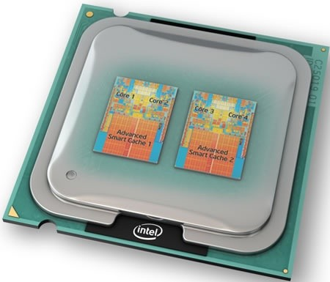 I won’t go into *too* much detail on cores, but since we’re discussing the CPU, cores are quite relevant. The model of the CPU in the diagram above was of a single-core processor. Almost all present day CPUs (not including microprocessors, since those are usually single core), are multi-core. If a CPU has two cores, we are quite literally saying that it has 2 CPUs within physical unit that you bought from the store. The image on the left is of an Intel quad-core CPU (not sure what specific processor it actually is). It may be hard to see, but there are labels showing the 4 physical cores, which are separated into 2 dies. Each die has 2 cores which share some advanced smart cache.

With the introduction of the early Pentium 4 CPUs from Intel, came a new technology – logical cores. Logical cores are essentially CPUs that are programmed in software. These do not physically exist on the CPU, but they can still perform an equal amount of workload as a physical core. Typically, each physical core has it’s own dedicated logical core. So for example, my current CPU, the Ryzen 7 1800X, has 8 cores, except that’s the physical core count. On my computer, it actually shows as having 16 cores because for every physical core, I have a logical core running in software. Each core counts as a single “thread” of execution. This means that each core can perform one task at a time. Collectively, the cores of a CPU run in parallel, meaning that many threads of execution are running concurrently. Although we won’t go into it much, threads become very important when you begin programming actual large-scale projects, since we can have multi-threaded applications. Knowing which cores these threads are executing in can be very useful for measuring performance.

Integrated Circuits (ICs):

I’ve briefly mentioned Integrated Circuits, or ICs, but I’d like to briefly elaborate on these a bit more. The terms “integrated” and “embedded” get thrown around a lot on the hardware level. There is no real distinction between these two words, so for the sake of clarity, I won’t argue semantics here, and just pretend that they are synonymous. An IC generally refers to a chip that has many circuits working in unison to complete some task. In recent years, much of the hobbiest/collector gaming community has become infatuated with FPGA technology. FPGA stands for Field Programmable Gate Array. FPGAs are an example of a semiconductor IC where much of the components can be changed by the design engineer or end user. FPGA are nice because they can emmulate older hardware with off the shelf components that you can find today (many old chips are not manufactured anymore due to their low demand).

Another form of IC are SoCs (System on a Chip). SoCs are typically microprocessors that have additional built-in functionality. For example, many CPUs integrate a graphics-sub system so that a dedicated graphics card is not necesarry. SoCs are very popular within smartphones, tablets, and embedded systems like WiFi routers and the Internet of Things (IoT).

PCBs and MotherBoards:

I think it’s time that we moved away from processors and focused on something else. Printed Circuit Boards (PCBs) are thin boards (usually made from copper plates and some sort of substrate that separates those plates. Each plate of copper is considered to be a “layer” of the PCB. Modern day PCBs can have up to 60 layers! This is basically equivallent to stacking 60 circuit boards on top of each other, except now it’s extremely compact. While it’s cool to have multi-layered PCBs, the only use for them is to route traces underneath each other. The actual components that live on PCBs must go on the top or bottom since they are too large to fit in between layers, plus it would be impractical to embed them within the board even if we could. Common components include transistors, resistors, capacitors, switches, diodes, LEDs, etc. Typically, solder mask is applied to the PCB before components are soldered to it. The solder mask prevents moisture and other external forces to affect the flow of electricity along the traces. Your PC has a large PCB which acts as a relay for almost all of the hardware to connect to. This PCB is called the MotherBoard (MB). It’s sort of like the circulatory system of the PC, circulating “blood” ie. electricity, to each part of the computer.

MotherBoard Form Factor:

Back in the late 1980s, most MBs were considered to have an Advanced Technology (AT) form factor. AT MBs drain more power, as they do not have a sleep mode feature. They use a 12-pin connector to connect to the Power Supply Unit (PSU). The AT form factor was introduced in 1984 by IBM.

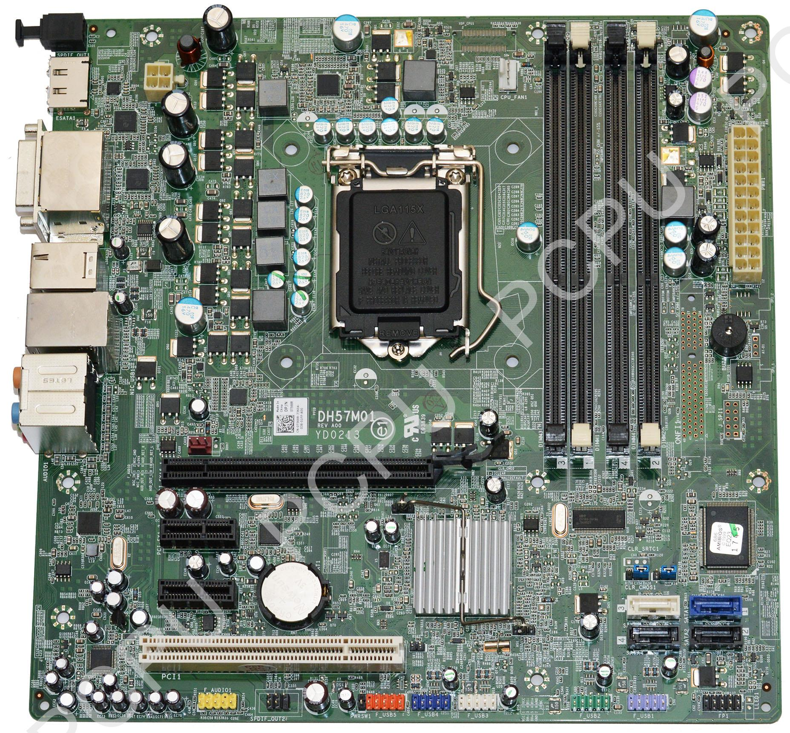

In 1995, a new form factor, Advanced Technology Extended (ATX) was created by Intel. ATX MBs have sleep mode features built-in, drain less power (since they can make use of modern PSUs), have 20 or 24-pin connectors for the PSU, and have many more connectors.

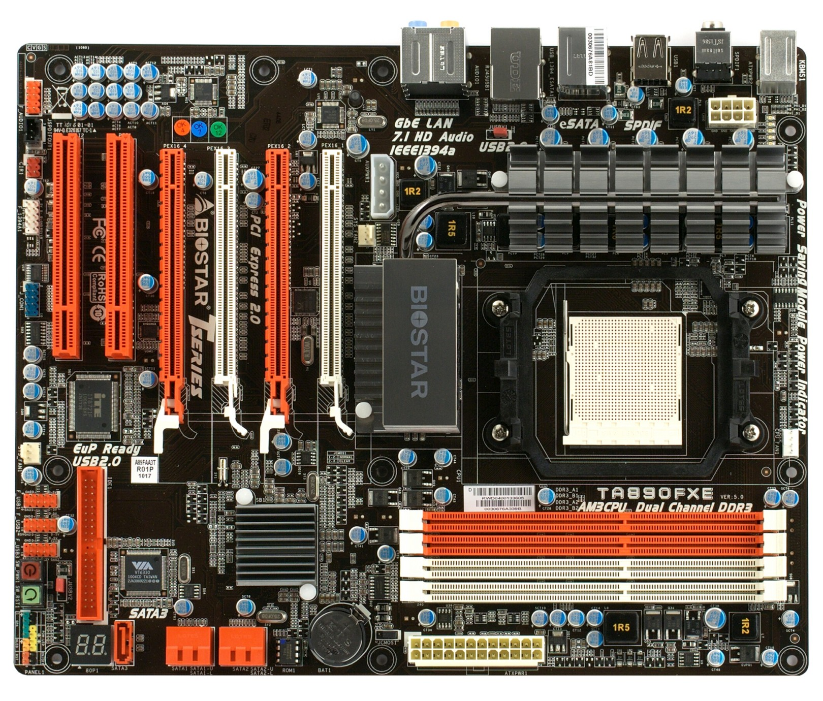

Chipset:

All MBs have a “chipset”. The chipset, in a nutshell, acts as the MB’s communications center and traffic controller, and determines what components are compatible with the MB. Most importantly, this includes the CPU socket type. Not all processors have the same pin layout, and Intel and AMD use two different approaches to the contacts on their CPUs, so MBs are not a one-size-fits-all. The chipset also includes things like the PCI(e) ports, built-in WiFi (or lack-there-of), etc.

BIOS and CMOS:

Your MB has an important chip called the Basic Input Output System (BIOS). The BIOS is a Read Only Memory chip (ROM) that checks the hardware on startup, and also contains the firmware for your computer. The BIOS is capable of doing very low level functions such as tuning voltages, fan speed, selecting the primary, secondary, tertiary, (etc.) boot drive, and much more.

The BIOS is linked to another chip on your computer called a Complementary Metal-Oxide Semiconductor (CMOS) chip. This chip is powered by a lithium coin-cell battery and keeps track of the Real-Time Clock (RTC). When your computer is powered off, the lithium battery continues to deliver power to the CMOS so that it can continue counting seconds. Otherwise, you’d have to reset your clock every boot (which used to be the case on old DOS computers)! The BIOS usually displays the clock time as well.

Accessing your BIOS depends on the manufacturer of the BIOS chip. Big names for BIOS chips are Award, AMBIOS, and Pheonix. These three use different keyboard keys (typically Function keys that begin with ‘F’) to enter into the BIOS. When your system is booting, you should see a splash screen stating the correct key to press to enter the BIOS. This usually happens very fast, so you need to mash the key, usually.

POST:

POST stands for Power On Self Test. One of the first things that happens when you power on your PC is that the BIOS does a POST to test that there are no issues with the computer components. Unpluggin a fan, for example, will cause your PC to enter the BIOS and warn you about it. Similarily, sometimes a warning is issued if no keyboard is detected. Often-times, an LED indicates the status of the POST, and in older computers, beep codes were(/sometimes still are) issued to notify the user of issues. Beep codes only work if the MB has a built in speaker, and work sort of like morse code with long beeps and short beeps meaning denoting different problems.

Boot Terminology:

There are two terms that you should familiarize yourself with when it comes to booting your PC. A cold boot is when a user shuts down the computer completely and then boots the computer from blank state. The CPU uses some sort of reset to initialize it to a stable state on power on, so cold boots are good for troubleshooting. A warm boot refers to a reboot of the system. Rebooting is not technically the same as a cold boot. A warm boot will bypass POST, and possibly other hardware initialization.

External Storage:

External storage, sometimes called auxiliary or secondary storage, is any storage medium which is not part of the CPUs MU, and is not MM. This includes Hard Drives (HD or HHD), Solid State Drives (SSDs), Non-Volatile Memory (NVMe), Flash Drives (such as thumb/USB/pen drives), Compact Disks (CDs), Digital Versatile Disks (DVDs), floppy drives, cassettes, etc. We will cover most of these storage mediums and explain key differences between each. At the end of the day, each of these storage mediums store data. Some are more or less reliable than others, and some have quicker access times or write times than others.

ROM/PROM/EPROM/EEPROM:

In the early days of computing we had Read-Only Memory (ROM). ROM is any form of storage that can only be read from, not written to. Typically, this would come in the form of a microchip, however, ROM can be any storage medium that is read-only. On old consoles or arcade machines, for example, a ROM chip would contain all of the game’s code. Whereas ROM is a category of storage, Programmable ROM (PROM) is a subset of ROM. A typical PROM comes with all bits reading as 1s. Burning a fuse bit causes the bit to be read as 0 by blowing the fuses, which is an irreversible process. Later, we got Erasable PROM which was a form of PROM that could be reset back to a default state by exposing the die to UV light. The final adaptation of ROM was Electrically Erasable ROM (EEPROM) which can be erased by sending electric signals to the pins. This was much simpler than exposing the die to UV light, and much less prone to being accidentally erased. An EEPROM programmer device is a little box with slits that line up with the EEPROMs legs. A latch clamps down on the legs and the EEPROM is reprogrammed by uploading a program from the computer to the EEPROM programmer.

Floppy Disks:

Floppy Disks are pretty much an obsolete form of storage used in the early days of Personal Computers. A dedicated peice of hardware, aptly called a floppy disk drive (FDD), would contain a slot for the user to insert the floppy disk. The term floppy disk comes from the fact that the disk itself is made of a flexible, magnetic material. This disk is encased in plastic housing that reduces the “floppiness” of the disk, so the name floppy disk is slightly misleading. As I mentioned, floppys are composed of magnetic sectors that can be magnetized or demagnetized. The magnetization and demagnetization of these sectors are read by the FDD as 1s or 0s. The disk would spin inside of the plastic casing at 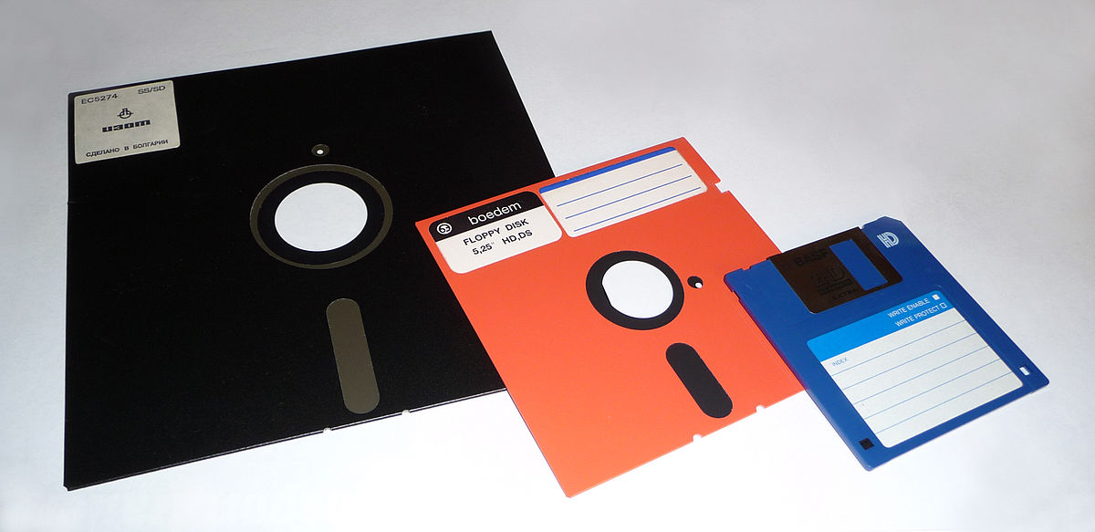fast speed to be read. A notch was usually carved out of the casing to indicate write protection so that the floppy couldn’t easily be overwritten. Despite the attempt to prevent data corruption, the magnetization on floppy disks is quite weak, so most disks remaining today are corrupted. There were 3 main sizes of floppys that were produced: 8-inch, 5-1/4 inch, and 3-1/2 inch.

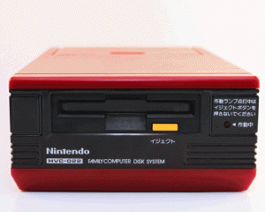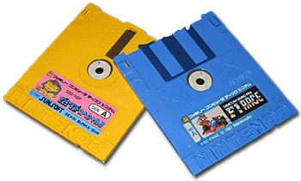 My favorite floppys are the ones that were used in the Famicom Disk System. Nintendo’s first console release in Japan was the Famicom which stood for Family Computer. The Famicom was Japan’s version of the NES, and played many of the same games. In 1986, the Famicom Disk System was released in Japan as an add on to the Famicom. It read small, proprietary floppy disks. These disks were double sided and could be taken to kiosks called the Nintendo Disk Writer that would repogram the floppys to have new games on them. For this reason, it is very difficult to find floppys for the system that still contain the same game that they released with.

CDs:

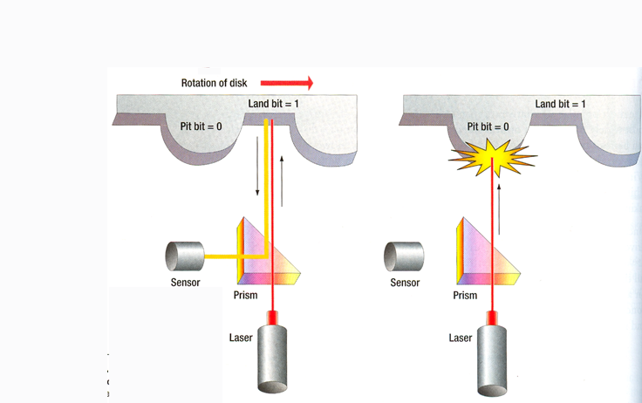 Compact Disks, often called by their abbreviation, CDs, are disks similar to floppys, but that are not magnetic and do not have an external housing. CDs are usually made out of a very thin layer of aluminum or gold that is pressed between two pieces of transparent polycarbonate. While still digital, CDs are considered to be an optical form of data storage. CDs are writable, but they are one time use. A stock CD has a flat layer of foil and therefore contains no data. In order to write to a CD, a very concentrated laser burns pits (indentations) into the foil. Anywhere that is not a pit is called a land. When the laser is not writing to the disk, it is reading from the disk. The laser is angled such that when it shines over one of the pits, the light is refracted into an optical sensor that interprets the light as a bit of information. CDs start along the interior and spiral their way outwards. This is opposed the

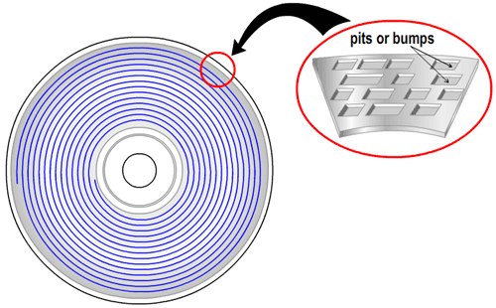

concentric rings found in floppys. CDs could store a lot of data for their era, making them a wildly successful form of data storage. Unfortunately, CDs are susceptible to damage, and are beginning to decay. The foil of CDs lie much closer to the label-side of the CD, so scratching that side is more likely to damage the disk. The clear side of the CD was designed to be able to be polished by special machines to get rid of scratches, so that side is not as impervious to damage. The glue used to hold the polycarbonate pieces together has also lost a lot of its bonding strength, and therefore CDs are known to split down the middle (albeit somewhat of a rare occurence). Finally, a strange phenomenon known as disk rot has begun to plague optical media a few centuries after the inception of CDs. Disk rot is thought to be caused by moisture and/or exposure to UV light, but its true culprit is unknown. Many versions of CD were released, including audio CD, Super Audio CD, CD-MIDI, Video CD, Super Video CD, Photo CD, CD-i, CD-i Ready, Enhanced Music CD (CD+), and VinylDisc.

HDD/HHD:

Hard Disk Drive (HDD) and Hybrid Hard Drive (HHD) are storage devices that use electromagnetism to store data. One or more metal platters are stacked on a rotating motor. The platters are coated with magnetic material segmented into tiny squares. A mechanical arm which rotates on one axis moves back and forth to access these segments on the platter. It is able to read data by determining if the segments are magnetized (1) or demagnetized (0). This is how the hard drive reads data. It may also write data by magnetizing or demagnetizing segments. Hard drives are a type of non-volatile storage. Because the actuator arm takes real time to move into place, as well as the time it takes for the platter to rotate into the correct position, hard drives are by todays standards, a slow medium for data R/W operations. They are, however, quite reliable and do not face the same issue as flash storage where cells wear out and are rendered useless. A hard drive is much more likely to have a mechanical failure such as a head crash, in which the actuator arm makes contact with the platter and destroys it as it spins.

A HHD (sometimes also known as a solid-state hybrid drive (SSHD)) is a mass storage device that combines a HDD and a NAND flash module (we will cover NAND flash shortly). Data which is frequently accessed for R/W operations is stored in the flash module, whereas data that is not touched often is stored on the platters. This is because, as mentioned previously, accessing data is slow on HDDs, but storing data on platters is arguably more reliable than on flash. The cost to storage ratio is also much weaker for flash storage (i.e. higher prices for not as much storage as on a HDD).

Flash:

Call me strange, but I find flash storage to be quite fascinating. Flash storage is a non-volatile storage medium which can be erased, and rewritten to i.e. reprogrammed. The interesting thing about flash is that it comes in two types: NOR flash and NAND flash, which are derived from NOR and NAND gate circuits, respectively (although, despite what the names might suggest, they are not “made-up” of these gates). They both use a technology known as floating gate MOSFETs. The confusing naming scheme is derived from the behavior of pulling the “bit lines” and “word lines” high or low which make them act similarily to NOR and NAND gates. Flash was based off of Electrically Erasable Programmable Read-Only Memory (EEPROM) technology. Whereas EEPROMs had to be completely wiped and re-written to, flash storage reads and writes data in blocks called pages. This allows us to erase specific sectors of storage, rather than the entire thing. With that out of the way, let us discuss the differences of NOR Flash vs. NAND Flash:

**NOR Flash:** NOR flash is a reliable form of storage. Bits are preserved with 100% effectiveness for the duration of the storage unit. It provides enough address lines to map an entire page of memory. This allows for random access, and shorter read times. The downsides to NOR is that it is more costly than NAND flash, and that write and erase speeds are slower on average.  
  
**NAND:** NAND Flash has much higher write speeds than NOR Flash, but slower read speeds. The biggest disadvantage of NAND Flash is that it is unreliable. Bits are preserved with 98% effectiveness, but what we call “bad blocks” arise rampantly throughout the parts lifetime. For this reason, an entirely new chip must be integrated into the board, known as a Flash Memory Controller chip. This performs error checking to fix bad blocks in the NAND storage. Because of the reduced cost, NAND is more commonly used than NOR Flash (it can be found in SD cards, USB drives, SSDs, etc.)

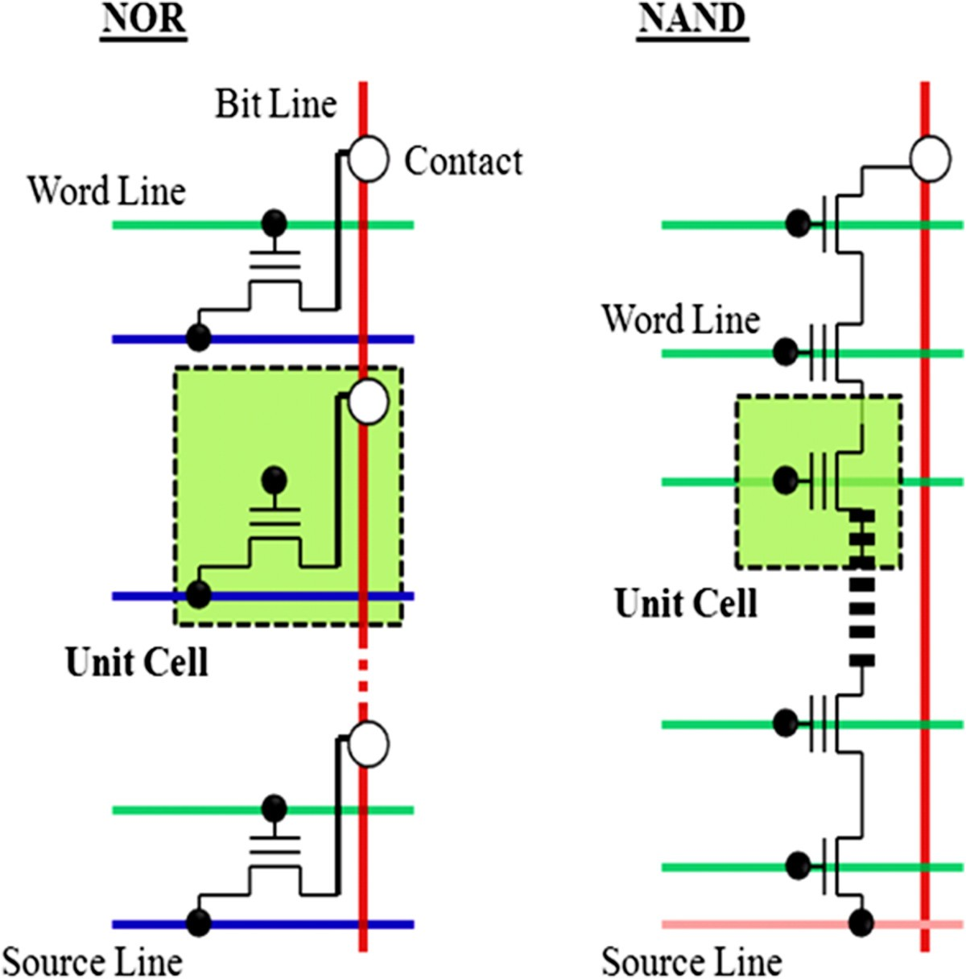 In this diagram, we can see the layout of several memory cells in both NOR and NAND Flash Architectures. If you’re not familiar with MOSFETs, I’ll quickly recap. The middle leg is known as the drain, and the other two legs are known as the source and gate. Under normal circumstances, no current flows through the source to the drain. If current is applied to the gate, however, then an electrical potential difference (voltage) is created between the source and drain, and thus current can flow from the source out the drain. This diagram is also deceptive, because it looks like all we’re dealing with is MOSFETs, when in reality, we are dealing with Floating Gate Metal Oxide Semi-Conductor (FGMOS). FGMOSs behave just like regular MOSFETs, however, they have an additional layer of insulent which is capacitive, and can store electrons for long periods of time (up to 10 years!) Beginning with NOR Flash, the source of the FGMOS is connected to the source line (blue), the gate is connected to the word line (green), and the drain is connected to the bit line (red). If we apply current to the word line, then current from the source line can go out the bit line. By applying current to the source line, we effectively select the column of memory cell that we want to access, and then by applying current to the word line we select the row. Whatever the Floating Gate (FG) contains will be put onto the bit line for us to read.

In the case of NAND Flash, the source and drains of each FGMOS are daisy chained together. This ones a bit more confusing so you’ll have to bear with me. In this scenario, notice that the bottom and top MOSs are actually just a regular MOSFETs, but each MOS in between is an FGMOS. The top MOSFET is the bit enable line, and the bottom MOSFET is the ground (GND) enable line. Imagine that current is always flowing through the source line, however, it can’t pass the first MOSFET unless the GND enable line is set high. Once that is set, we select the appropriate word line. What this diagram does not show, which makes it so confusing, is that there is a hidden line underneath the FGMOSs called a Tunnel Oxide which allows us to read the bit stored in the memory cell. When we are ready to read the bit, we set the bit enable line high which allows the bit from the FG to travel through the Tunnel Oxide to the bit line. For a better illustration, see <https://user.eng.umd.edu/~blj/CS-590.26/nand-presentation-2010.pdf>.

SSD:

A Solid-State Drive (SSD) is the modern equivallent to HDDs. It uses flash memory rather than physical platters, meaning that R/W operations are performed digitally. Previously, we looked at flash cells, which are the units of storage for flash memory. As of the time of writing this, a cell can contain between 1 and 4 bits of data. The most reliable, durable, fast, and expensive type are Single-Level Cells (SLC) which contain 1 bit per cell. Multi-Level Cells (MLC) is 2 bits, Triple-Level Cells (TLC) is 3 bits, and Quad-Level Cells (QLC) is 4 bits respectively. SSDs come in various form factors. The standard form factor is simply known as SSD, but others include mSATA SSDs, M.2 SSDs, U.2 SSDs, NF1/M.3/NGSFF SSDs, XFM Express SDDs, and EDSFF SSDs.

NVMe:

Non-Volatile Memory (NVM) and NVM Express (NVMe) A.K.A Non-Voltaile Memory Host Controller Interface Specification (NVMHCIS) is an open, logical-device interface specification for accessing a computer’s non-volatile storage media (usually attached via PCIe). Most people conflate M.2 SSDs with NVMe. They are not equivallent terms, however, they are related. Since M.2 drives use PCIe for communication, they can be considered to use the NVMe specification. A dedicated NVMe controller chip is physically co-located within the storage media.

eMMC/SD:

The MultiMediaCard, abbreviated as MMC, is a memory card standard used for solid-state storage which was created by SanDisk and Siemens. Many folks, including myself, get confused thinking that MMC and Secure Digital (SD) cards are the same thing. Although they look extremely similar, and behave similarily, they are two separate standards. MMC is essentially obsolete now with the rise of SD cards.

There are many variants of MMC such as RS-MMC, DV-MMC, MMCplus, MMCmobile, MMCmicro, MiCard, SecureMMC, and the one that we care about most, embedded MMC (eMMC). Unlike the MultiMediaCard, which resembles an SD card, eMMC comes in the form of Ball Grid Array (BGA) IC packages. These are not obsolete, and are actually quite common on modern boards such as the majority of Raspberry Pis and many cellphones as well.

SD cards come in various form factors including standard SD cards, miniSD, and microSD. The capacities that an SD card is able to store are labelled. For example SD can store up to 2GB, SDHC can store 2GB-32GB, SDXC can store 32GB-2TB, and SDUC can store 2TB-128TB! At the time of writing this, no SD cards with over 1TB of storage have actually been manufactured, so the SDUC standard is relegated until the future when we are actually capable of storing that much data in an SD card.

Buses:

I said that we’d come back to buses and I’ve kept my word. As we’ve already covered, a bus is just a series of traces that inter-connect two peripherals for communication. Bus communication can happen in one of two ways: serial connections or parallel connections. In a serial connection, a single line is often reserved for transmission (Tx), and a single line is reserved for recieving (Rx). Using Universal Serial Bus (USB) as a commonly understood example, we know that it has 4 gold plated metal prongs. This represent Vss (power), Vdd (GND), Tx, and Rx. Since serial communications are asynchronous, meaning that bits are streamed without a shared clock pulse, the sender and reciever must agree on a common baud rate. Baud is the agreed maximum rate at which data can be transmitted through serial. Standard UART baud rates are 9600, 19200, 38400, 57600, and 115200, etc. (we’ll cover UART soon). Serial communications also need a stop bit after each byte to indicate that a full character has been sent. Parallel communications are synchronous, meaning that a clock is shared between the sender and reciever to synchronize the timings that they send and recieve data at. Devices communicating in parallel send one bit per line, meaning that the recieving device must be able to handle reading in multiple bits at once. Parallel communications are slower than serial communications, but are more reliable.

Buses can either be external (such as a physical wire connecting a peripheral like a mouse, keyboard, or printer), or internal (usually traces etched into the Mother Board (MB). We can further categorize buses into 3 types: Control buses, Data buses, and Address buses.

**Control Bus:** A control bus is a series of signals that collectively maintain the state of the system. The control bus is most often responsible for hardware timing signals.

**Data Bus:** A data bus is specifically the bus between the primary processor (CPU, usually), and MM (RAM, usually).

**Address Bus:** An address bus is used to specify a physical address of some device. This is most commonly used in Direct Memory Access (DMA) for reading or writing from/to some physical address (as opposed to a virtual address). The width of the address bus determines the amount of memory a system can address. For instance, a 32-bit address bus reading or writing 1 byte at a time would mean that the amount of *addressable space* is 4 GiB.This is because there are literally 32 traces in the computer that can each send a binary signal (on/off) to select a specific address. As we know 2^32 = 4,294,967,296 (4 GiB) of possible addresses.

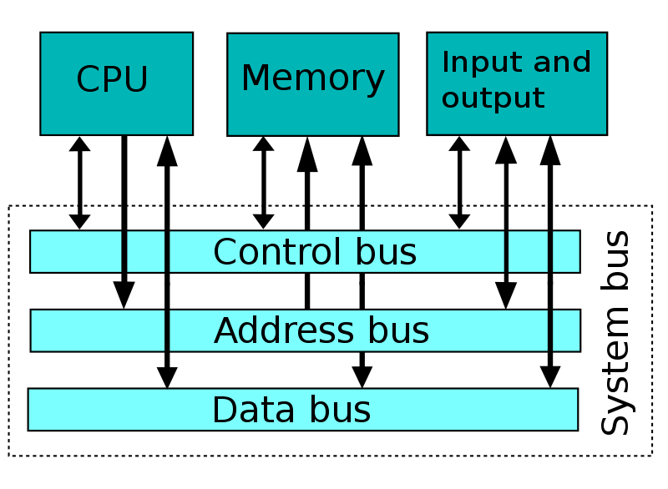

Bus Communication Protocols:

There are many forms of bus communication protocol. They each serve unique purposes. You may wonder why we don’t have a unified method of transmitting data through buses. This comes down to differences in peripherals. Typically, a new bus communication protocol is created for a specific *kind* of hardware peripheral.

**ISA / I/O Channel:** Not to be confused with Instruction Set Architecture (also ISA), Industry Standard Architecture, also known as I/O Channel, is the 16-bit internal bus created by IBM. A later attempt to extend ISA from 16-bit to 32-bit, known as Extended ISA (EISA), was not very successful. Although it is no longer used in home computers, certain industrial computers which never made the transition to using PCI/PCIe still use ISA.

**IDE & PATA & SATA:** Integrated Drive Electronics (IDE) was primarily used for connecting both optical drives and hard drives to the MB. IDE has essentially been phased out at this point. Advanced Technology Attach (ATA) comes in two forms: Serial ATA (SATA), and Parallel ATA (PATA). PATA and SATA are primary used for hard drives. PATA uses wide, but thin ribbon cables with multiple connection points and looks almost identical to an IDE cable. SATA, on the other hand, uses thin wire with two end point connections. Due to the fact that SATA is much faster than PATA, it is the standard for modern SSDs.

**PCI & PCIe:** PCI and PCIe are likely the most important bus protocols out of this list (though PCI is essentially obsolete). Peripheral Component Inter-connect (PCI) and the extended standard (PCIe) are meant to be extremely quick bus interfaces, usually used by graphics cards, network cards, audio cards, and NVMe M.2 drives. Even more confusing is that PCI has had a few different iterations. At the time of writing this (2022), the standard is PCI 3.0, and PCI 4.0 is in its infancy. What makes PCIe so fast is that it is directly connected to the CPU. There are 7 kinds of PCI slot: x1, x2, x4, x8, x16, x32 (all powers of 2). These correspond to the number of lanes. Note that the number of lanes does not necessarily equal the number of bus traces. I have seen official documentation describing the PCI specification that was a thousand pages long, so obvsiously there is a lot more to be said about PCI that I cannot cover in this document.

**I2C / IIC:** I2C (which is actually I to the power of 2 C, pronounced “I squared C”) is a synchronous serial bus communications protocol invented by Philips Semiconductors. It is primarily used for connecting lower-speed peripherals to microprocessors/microcontrollers over a short distance. I2C is commonly used for its simplicity. It is a bi-directional (2 wires - or 2 pullup resistors, to be exact) system where one line is used for the serial clock, and the other is used for data. Common voltages are 5V and 3.3V.

**SPI & QSPI:** Similar to I2C, Serial Periperal Interface (SPI) and Quad SPI (QSPI) are bus interfaces for inter-connecting hardware components such as shift registers, sensors, and SD cards to microprocessors/microcontrollers.

**AMBA:**

**AXI:**

**CoreConnect:**

**Wishbone:**

**SBA:**

The Bus Master:

In a traditional computer architecture, there is one IC (usually the CPU) that controls the active bus. The IC which controls the active bus is called the bus master. Imagine that a system has a CPU, some ROM, RAM, and perhaps a peripheral interface chip. The CPU is only capable of accessing one of these at a time. For instance, it might want to access the contents of RAM at a particular address, so it sends the requested address over the address bus that connect the CPU and RAM, and then the RAM chip will reply with the data located at that address over the data bus. Note that other ICs, such as the peripheral interface chip, have no ability to access RAM directly in the same manner as the CPU. So if the peripheral interface chip requires some data from RAM, the CPU must fetch it, and then send it to the peripheral interface. DMA is the act of allowing components which are not the bus master, to communicate with other components directly. More on this in a bit.

Universal Serial Bus (USB):

We’ve already discussed USB, however most people don’t realize how deep USB actually goes. This is to be expected since USB was designed to unite I/O port interfaces (one for all and all for one). It can be disputed how effective the standard actually was at acheiving unity. Whilst many devices do use USB, the fact is that there are many types of USB connectors, and to make matters worse, each type has multiple specifications. The USB-IF is the organization responsible for creating all of the specifications for USB, and they have official documentation which describe each new standard.

**Type A:** USB-type A is the most common type. It is the rectangular-like connector that is found on the majority of computers. USB-type A can come in 3 primary standards: USB 1.0, USB 2.0, and USB 3.0. Sub-standards also exist, such as USB 3.1 Gen1, USB 3.1 Gen2, USB 3.2, etc. All of these standard primarily specify power draw and speeds. Unfortunately, the standards for USB-type A have become increasingly confusing, which is likely the reason that companies are trying so dilligently to move towards type C (which already has its own flaws).

**Type B:** USB-type B is likely the least common form of USB. It can be described as having a house shaped connector (almost a perfect square but with the top left and top right corners being cut at a 45 degree angle). They are most commonly found on printers (another place I can think of them is on the Arduino Uno). Type-B really has no reason to exist as far as I can tell. The argument is that it is less likely for you to accidentally plug the wrong ends in, but this argument is moot in my opinion.

**Type C:** USB-type C is an eliptically shaped connector that is becoming increasingly popular for its incredible speeds and somewhat due to the fact that the connector can be plugged in at any orientation (unlike all other types on this list other than lightning). This is the standard for phone charging ports. The reason that it has taken long to become popular is due to the fact that there are already so many USB-type A ports in existence, and also because the cost of USB C is more than that of USB A. Similar to USB-type A, C already has issues with standards with the fact that there exists USB-C Gen1 and Gen2, similar to USB 3.x Gen 1 and 2.

**Micro USB:**

**USB Mini:**

**Lightning USB:**

USB on-the-go (OTG):

USB Mass Storage:

USB Mass storage is a USB device (typically something like a flash/thumb drive) which implements the USB Mass Storage device class (sometimes called USB MSC or UMS). The MSC is a set of protocols defined by the USB Implementers Forum which allow a USB device to act as the host, or client device and vice versa. This is how file transfers occur, for example. This is also why your phone may ask you to specify what type of operation you wish to use the USB connection for when plugging it into a computer.

Host Controller Interface:

Universal Asynchronous Receive/Transmit (UART):

UART is one of the most common device-to-device communication protocols. The name, “Universal Asynchronous Receive/Transmit” suggests that the device is capable of tansmitting and recieving data asynchronously (i.e. not driven by a shared clock, as you would find in parallel communication). The duty of UART is to provide data communications between two devices. This data can be any combination of serial to serial, parallel to parallel, serial to parallel, or parallel to serial. The way that it works is using shift registers, which are very low-level hardware devices that shift bits left or right using flip flops. Putting multiple shift registers in series allows us to to shift data into the receive and transmit buffers of the UART device. UART is very simple because we only have 2 lines, similar to I2C, only in this case, they are for Rx and Tx respectively. Synchronization is managed by baud rate alone, and both the master and slave UART devices must agree on using the same baud rate.

There are two leading standards used for UART: RS-232 suggests using 12V when setting the line high and RS-485 using 5V when setting the line high. UART is most commonly used for character devices. The 8250 UART is by far the most well known UART device (comparable to the fame of the 6502 or 8086 microprocessors). Communications between UART devices can occur in 3 modes: simplex, half duplex, or full duplex. If you’re familiar with networking, you may be familiar with the latter two (or maybe even all three, I’m not sure). In simplex mode, the data can only be sent in one direction (uni-directional). The master in this case would only recieve data, and the slave device would only transmit it. In a half duplex system, both devices take turns transmitting and receiving data. Finally, in a full duplex system, both devices can transmit and recieve at the same time.

Data is sent in frames, simply known as UART frames. A frame consists of the following:

**Start bit:** This bit signals that a new character is incoming.

**Data bit:** The next five to nine bits, depending on the code set, represent the character.

**Parity bit:** The parity bit, if used, is a check bit used to detect errors.

**Stop bit:** This bit marks the end of the UART frame.

One final note about UART is the existence of Universal Synchronous and Asynchronous Receive Transmit (USART). This type of device functions the same as a regular UART device but also allows for synchronous (with a clock) communication between master/slave, unlike normal UART, which only supports asynchronous operations.

Direct Memory Access (DMA):

DMA Controllers:

Memory Management Unit (MMU):

The Memory Management Unit, sometimes called Paged Memory Management Unit (PMMU), is a hardware unit that performs the necessary translations between Physical Address Space (PAS) and Virtual Address Space (VAS). Nowadays, the MMU is generally integrated into the CPU or SoC, however, it used to be its own micro controller. The MMU not only creates the proper lookup translations, but also deals with memory protection (generating interrupts when an invalid memory access is performed), cache control, etc.

Translation Lookaside Buffer (TLB):

The Translation Lookaside Buffer is a cache located within the CPU that keeps track of recent memory mappings. Whenever a request is made to access memory, the MMU first references the TLB to check for recent mappings in hopes that the memory being accessed belongs to a process that was recently created. This essentially functions the same as the dcache or icache, but for memory mappings rather than data or instructions.

IOMMU/SMMU:

We learned that the MMU belongs to the CPU, however, other devices can also have their own MMUs. On the x86 architecture, these are called I/O MMUs (making a reference to the fact that x86 uses a port I/O system for communication with devices). On ARM, these are called SMMUs (System MMU). Most commonly, these MMUs are used on DMA-capable I/O devices such as graphics cards, NICs, etc. The core difference between the MMU on the CPU and an IOMMU/SMMU is that the MMU created translations between physical addresses in MM and virtual addresses. An IOMMU or SMMU creates translations between phyical addresses in MM and devices addresses. You likely don’t realize this, but PCI devices have their own PCI addresses (sometimes called device addresses), separate from PAS or VAS. This is useful for a few reasons:

1. It can securely allow a VM to use DMA with native drivers

2. It decouples the device’s addressing capabilites from PAS. In other words, it lets you have devices which can only do 32-bit addressing access data anywhere in physical memory, even above the first 4G (32-bits = 4G of address ranges).

3. It lets you isolate devices from each other more thoroughly, which can improve security.

All Things Memory:

Pageable vs Wired:

The MMU has one of two options when it comes to mapping physical addresses into virtual addresses. The first option is known as wired memory, which is when the entire PAS requested for mapping is mapped to VAS at the moment it is requested. In other words, each byte of the physical memory requested for mapping is mapped to a corresponding virtual byte. Assuming the hardware supports it, however (which it normally does), the alternative method is to use pageable memory, also known as on demand paging. This is when the MMU acknowledges the request to map PAS to VAS, but only actually ‘backs’ it (i.e. creates the mapping) at the time that the memory must be accessed. This is very similar to how Copy on Write (COW) works, but is not quite identical.

Video Processing Unit (VPU):

Harvard Architecture and Von Neumann Architecture:

There are two competing architectures which practically dominate the entire computing industry. These are the Von Neumann and Harvard architectures. Von Neumann is by far the most commonly used architectue in modern computers, and is likely what your PC is designed around. The Harvard architecture, however, is not completely obsolete, as it still lives on in certain microprocessors. Perhaps the most popular chips which use the Harvard architecture are the Atmel chips used in Arduino boards.

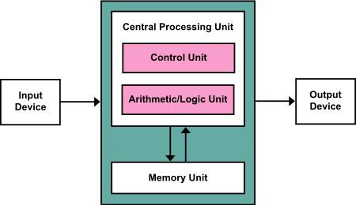Figure 1: Von Neumann Architecture

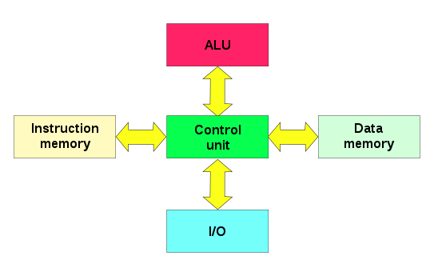Figure 2: Harvard Architecture

The primary difference between the two architectures is how they access data and instructions. With the Von Neumann architecture, the program data (variables) are located in the same memory as the program’s instructions. For this reason, instructions and data cannot be fetched at the same time, since they are both accessed over the same bus by the CPU. In Harvard architecture, on the other hand, separate memory is reserved for instructions and data, meaning that the CPU may access both data and instructions at the same time, even without a cache.

GPIO:

Pin Muxing:

Watchdogs:

JTAG:

Lauterbach:

Interrupt Vector Table (IVT) and Interrupt Descriptor Table (IDT):

Programmable Interrupt Controller (PIC):

Intel 8254 Programmable Interrupt Timer (PIT):

HPET:

Advanced Programmable Interrupt Controller (APIC) / LAPIC:

Startup:

BIOS and UEFI:

BIOS stands for Basic Input Output System and UEFI stands for Unified Extensible Firmware Interface. Both of these two things are simply firmware for your MOBO. There are many different BIOSes or UEFIs that are all relatively similar, but will differ depending on the capabilities of the MOBO. There used to be a ROM chip on the MOBO known as the BIOS chip which the MOBO manufacturer would flash a stock BIOS image onto. Nowadays, the BIOS/UEFI is flashed to flash memory. The BIOS/UEFI allow you to alter low level settings such as fan speeds, clock rates, voltages, boot sequence, etc. The difference between BIOS and UEFI is primarily how much support they provide for the limitations of the hardware. BIOS is an older standard that is essentially obsolete. We tend to still refer to UEFI as BIOS regardless. Here is an image of the legacy boot process (BIOS):

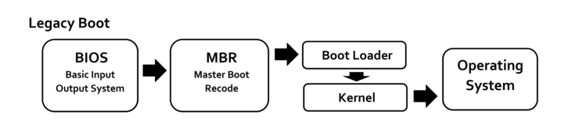UEFI uses GPT rather than MBR, so this is not how a modern boot process would look, but other than that, it is essentially the same. The firmware (BIOS/UEFI) starts, then transfers execution to a sector in disk which launches the boot loader which launches the kernel which launches all the appropriate services to be the full OS. There exist Free and Open Source (FOSS) BIOSes such as SeaBIOS which is used to coreboot a computer, and by emulators such as QEMU and Bochs. Coreboot removes the Intel Management System, which is essentially a backdoor on your system that you probably don’t want. Unfortunately, the coreboot process is somewhat complicated and can easily brick your system if not done properly.

u-boot and SPL:

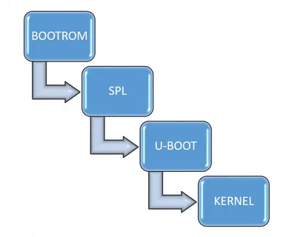 U-Boot stands for Universal Bootloader, and serves a similar purpose to BIOS/UEFI, but is for ARM platforms. BIOS/UEFI are x86 only, so something like a RaspberryPi cannot load a BIOS. Unlike BIOS/UEFI, U-Boot is both a first-stage and second-stage bootloader. It gets loaded by the system’s ROM (e.g. the onchip ROM of the ARM CPU) from a supported boot device, such as an SD card, SATA drive, NOR flash, or NAND flash. If there are size constraints in U-Boot, it can be spliy into two stages. The device can load an SPL (Secondary Program Loader), which is a stripped down version of U-Boot, which would then do low level hardware initialization. Once it completes, it loads the fully featured version of U-Boot. Either way, U-Boot performs the first-stage bootloading (hardware init) and second-stage bootloading (equivallent to the boot loader section of BIOS/UEFI where execution is transfered to the kernel). Similar to SeaBIOS, there exist FOSS U-Boot software. The most popular by far is called Das U-Boot which is under a GPL2 license.